**Lab 2: Design and Simulation of Sequential Logic Circuits**

**Fall 2018**

**School of Electrical Engineering and Computer Science**

**University of Ottawa**

**Professor: Dr. Fadi Malek**

**Group 6**

**Khang Nguyen 300007277**

**Syed Haider Rizvi 6842303**

**Experiment Date: September 24 2018**

**Submission Date: October 8 2018**

**Lab Problem:**

During the lab we will be making two synchronous counters with the use of JK flip flops. Through the objectives marked below, this lab is very important to introduce students to the design of sequential circuits based on Altera’s Quartus development environment and their implementation and testing with an FPGA.

**Objectives:**

* Enter the design of synchronous counters using Quartus II graphics editor
* Assign the input-output pins and prepare the design for downloading and testing on the Altera DE2-115 board
* Test the counter:

- Display the counter outputs as binary values on LEDs

- Using an oscilloscope, trace and record the waveforms at various flip-flops.

**Solution:**

To find the solution, we first drew the state diagram (given in the lab PDF). We then derived the excitation table for the circuit (refer to the appendix). After having derived the excitation table, we create karnaugh map for all the flip flops (refer to the appendix).

**Materials:**

* Quartus II 13.0 Service-Pack 1 Program
* Altera DE2-115 card
* KEYSIGHT InfiniiVision MSO-X 2012A

**Design:**

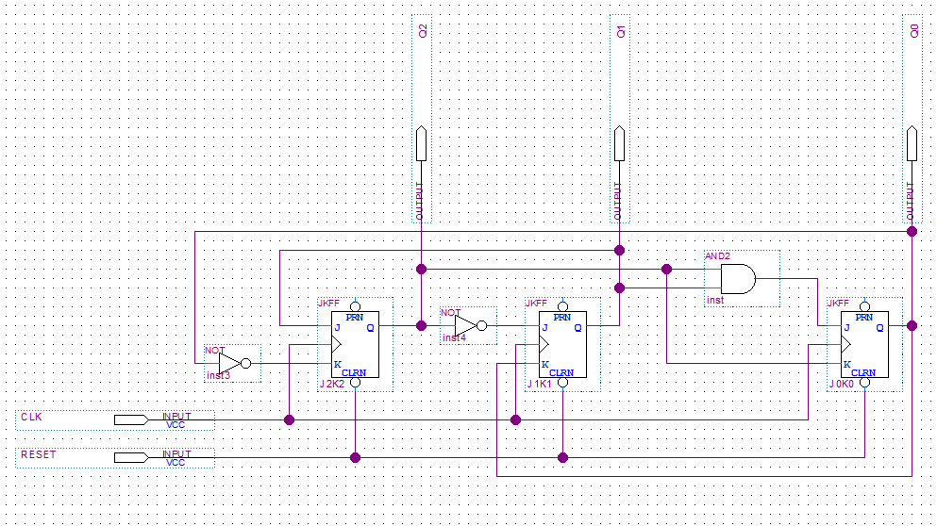

**Figure 1: Screen Capture of 3 bit Synchronous Counter with JK Flip-Flops**

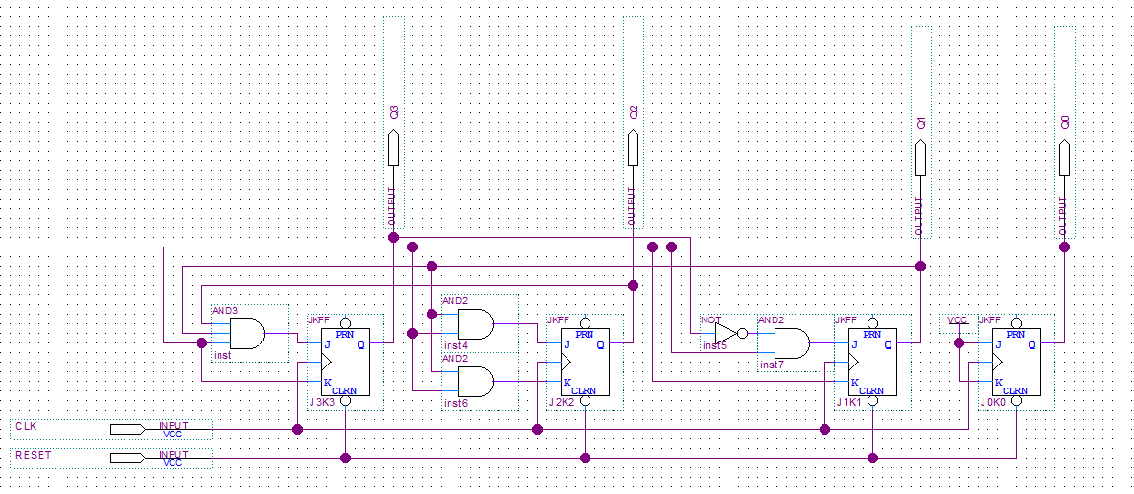

**Figure 2: Screen Capture of 4 bit Synchronous Counter with JK Flip-Flops**

|  |  |  |  |  |  |  |  |  |  |  |  |
| --- | --- | --- | --- | --- | --- | --- | --- | --- | --- | --- | --- |
| Present | | | Next | | | Synchronous Inputs | | | | | |
| Q2 | Q1 | Q0 | Q2 | Q1 | Q0 | J2 | K2 | J1 | K1 | J0 | K0 |
| 0 | 0 | 0 | 0 | 1 | 0 | 0 | x | 1 | x | 0 | x |
| 0 | 0 | 1 | x | x | x | x | x | x | x | x | x |
| 0 | 1 | 0 | 1 | 1 | 0 | 1 | x | x | 0 | 0 | x |
| 0 | 1 | 1 | 1 | 0 | 1 | 1 | x | x | 1 | x | 0 |
| 1 | 0 | 0 | 0 | 0 | 0 | x | 1 | 0 | x | 0 | x |
| 1 | 0 | 1 | 1 | 0 | 0 | x | 0 | 0 | x | x | 1 |
| 1 | 1 | 0 | 0 | 1 | 1 | x | 1 | x | 0 | 1 | x |
| 1 | 1 | 1 | x | x | x | x | x | x | x | x | x |

**Table 1 : Experimental Data Observed from the Altera DE2-115 Card Circuit for the**

**3-bit modulo 6 counter**

|  |  |  |  |  |
| --- | --- | --- | --- | --- |
| Q2\Q1Q0 | 00 | 01 | 11 | 10 |
| 0 | 0 | x | 1 | 1 |
| 1 | x | x | x | x |

**Table 2 : Karnaugh Map of Experimental Data Observed from the Altera DE2-115 Card Circuit for J2 = Q1**

|  |  |  |  |  |
| --- | --- | --- | --- | --- |
| Q2\Q1Q0 | 00 | 01 | 11 | 10 |
| 0 | x | x | x | x |
| 1 | 1 | 0 | x | 1 |

**Table 3 : Karnaugh Map of Experimental Data Observed from the Altera DE2-115 Card Circuit for k2 = Q0’**

|  |  |  |  |  |
| --- | --- | --- | --- | --- |
| Q2\Q1Q0 | 00 | 01 | 11 | 10 |
| 0 | 1 | x | x | x |
| 1 | 0 | 0 | x | x |

**Table 4 : Karnaugh Map of Experimental Data Observed from the Altera DE2-115 Card Circuit for J1 = Q2’**

|  |  |  |  |  |
| --- | --- | --- | --- | --- |
| Q2\Q1Q0 | 00 | 01 | 11 | 10 |
| 0 | x | x | 1 | 0 |
| 1 | x | x | x | 0 |

**Table 5 : Karnaugh Map of Experimental Data Observed from the Altera DE2-115 Card Circuit for K1 = Q0**

|  |  |  |  |  |
| --- | --- | --- | --- | --- |
| Q2\Q1Q0 | 00 | 01 | 11 | 10 |
| 0 | 0 | x | x | 0 |
| 1 | 0 | x | x | 1 |

**Table 6 : Karnaugh Map of Experimental Data Observed from the Altera DE2-115 Card Circuit for J0 = Q2Q1**

|  |  |  |  |  |
| --- | --- | --- | --- | --- |
| Q2\Q1Q0 | 00 | 01 | 11 | 10 |
| 0 | x | x | 0 | x |
| 1 | x | 1 | x | x |

**Table 7 : Karnaugh Map of Experimental Data Observed from the Altera DE2-115 Card Circuit for K0 = Q2**

|  |  |  |  |  |  |  |  |  |  |  |  |  |  |  |  |
| --- | --- | --- | --- | --- | --- | --- | --- | --- | --- | --- | --- | --- | --- | --- | --- |
| Present | | | | Next | | | | Synchronous Inputs | | | | | | | |
| Q3 | Q2 | Q1 | Q0 | Q3 | Q2 | Q1 | Q0 | J3 | K3 | J2 | K2 | J1 | K1 | J0 | K0 |
| 0 | 0 | 0 | 0 | 0 | 0 | 0 | 1 | 0 | x | 0 | x | 0 | x | 1 | x |
| 0 | 0 | 0 | 1 | 0 | 0 | 1 | 0 | 0 | x | 0 | x | 1 | x | x | 1 |
| 0 | 0 | 1 | 0 | 0 | 0 | 1 | 1 | 0 | x | 0 | x | x | 0 | 1 | x |
| 0 | 0 | 1 | 1 | 0 | 1 | 0 | 0 | 0 | x | 1 | x | x | 1 | x | 1 |
| 0 | 1 | 0 | 0 | 0 | 1 | 0 | 1 | 0 | x | x | 0 | 0 | x | 1 | x |
| 0 | 1 | 0 | 1 | 0 | 1 | 1 | 0 | 0 | x | x | 0 | 1 | x | x | 1 |
| 0 | 1 | 1 | 0 | 0 | 1 | 1 | 1 | 0 | x | x | 0 | x | 0 | 1 | x |
| 0 | 1 | 1 | 1 | 1 | 0 | 0 | 0 | 1 | x | x | 1 | x | 1 | x | 1 |
| 1 | 0 | 0 | 0 | 1 | 0 | 0 | 1 | x | 0 | 0 | x | 0 | x | 1 | x |
| 1 | 0 | 0 | 1 | 0 | 0 | 0 | 0 | x | 1 | 0 | x | 0 | x | x | 1 |
| 1 | 0 | 1 | 0 | x | x | x | x | x | x | x | x | x | x | x | x |
| 1 | 0 | 1 | 1 | x | x | x | x | x | x | x | x | x | x | x | x |
| 1 | 1 | 0 | 0 | x | x | x | x | x | x | x | x | x | x | x | x |
| 1 | 1 | 0 | 1 | x | x | x | x | x | x | x | x | x | x | x | x |
| 1 | 1 | 1 | 0 | x | x | x | x | x | x | x | x | x | x | x | x |
| 1 | 1 | 1 | 1 | x | x | x | x | x | x | x | x | x | x | x | x |

**Table 8 : Experimental Data Observed from the Altera DE2-115 Card Circuit for the 4-bit counter**

|  |  |  |  |  |
| --- | --- | --- | --- | --- |
| Q3Q2\Q1Q0 | 00 | 01 | 11 | 10 |
| 00 | 0 | 0 | 0 | 0 |
| 01 | 0 | 0 | 1 | 0 |
| 11 | x | x | x | x |
| 10 | x | x | x | x |

**Table 9 : Karnaugh Map of Experimental Data Observed from the Altera DE2-115 Card Circuit for J3 = Q2Q1Q0**

|  |  |  |  |  |
| --- | --- | --- | --- | --- |
| Q3Q2\Q1Q0 | 00 | 01 | 11 | 10 |
| 00 | x | x | x | x |
| 01 | x | x | x | x |
| 11 | x | x | x | x |
| 10 | 0 | 1 | x | x |

**Table 10 : Karnaugh Map of Experimental Data Observed from the Altera DE2-115 Card Circuit for K3 = Q0**

|  |  |  |  |  |
| --- | --- | --- | --- | --- |
| Q3Q2\Q1Q0 | 00 | 01 | 11 | 10 |
| 00 | 0 | 0 | 1 | 0 |
| 01 | x | x | x | x |
| 11 | x | x | x | x |
| 10 | 0 | 0 | x | x |

**Table 11 : Karnaugh Map of Experimental Data Observed from the Altera DE2-115 Card Circuit for J2 = Q1Q0**

|  |  |  |  |  |
| --- | --- | --- | --- | --- |
| Q3Q2\Q1Q0 | 00 | 01 | 11 | 10 |
| 00 | x | x | x | x |
| 01 | 0 | 0 | 1 | 0 |
| 11 | x | x | x | x |
| 10 | x | x | x | x |

**Table 12 : Karnaugh Map of Experimental Data Observed from the Altera DE2-115 Card Circuit for K2 = Q1Q0**

|  |  |  |  |  |
| --- | --- | --- | --- | --- |
| Q3Q2\Q1Q0 | 00 | 01 | 11 | 10 |
| 00 | 0 | 1 | x | x |
| 01 | 0 | x | x | x |
| 11 | x | x | x | x |
| 10 | 0 | 0 | x | x |

**Table 13 : Karnaugh Map of Experimental Data Observed from the Altera DE2-115 Card Circuit for J1 = Q3’Q0**

|  |  |  |  |  |
| --- | --- | --- | --- | --- |
| Q3Q2\Q1Q0 | 00 | 01 | 11 | 10 |
| 00 | x | x | 1 | 0 |
| 01 | x | x | 1 | 0 |
| 11 | x | x | x | x |
| 10 | x | x | x | x |

**Table 14 : Karnaugh Map of Experimental Data Observed from the Altera DE2-115 Card Circuit for K1 = Q0**

|  |  |  |  |  |
| --- | --- | --- | --- | --- |
| Q3Q2\Q1Q0 | 00 | 01 | 11 | 10 |
| 00 | 1 | x | x | 1 |
| 01 | 1 | x | x | 1 |
| 11 | x | x | x | x |
| 10 | 1 | x | x | x |

**Table 15 : Karnaugh Map of Experimental Data Observed from the Altera DE2-115 Card Circuit for J0 = 1**

|  |  |  |  |  |
| --- | --- | --- | --- | --- |
| Q3Q2\Q1Q0 | 00 | 01 | 11 | 10 |
| 00 | x | 1 | 1 | x |
| 01 | x | 1 | 1 | x |
| 11 | x | x | x | x |
| 10 | x | 1 | x | x |

**Table 16 : Karnaugh Map of Experimental Data Observed from the Altera DE2-115 Card Circuit for J0 = 1**

**Discussion of used Components:** The circuit contains JK flip-flops. The JK flip-flops next state stays the same if both J and K are 0. The flip-flops next state will be 0 if J is 0 and K is 1. The JK flip-flops next state will be the opposite of the current state if both J and K are 1.

**Discussion of Actual Solution:** With all the components working together, the 3 bit counter should count, 000, 010, 110, 011, 101, and 100 then restarting. The 4 bit counter should then count 0000, 0001, 0010, 0011, 0100, 0101, 0110, 0111, 1000, and 1001 then restarting. We used the simulation to test our truth table (explained below), and we were able to conclude that our design and derived truth table was correct.

**Discussion of Tool:** The tools we used were the Quartus II software and card. During the simulation process we were able to determine if we had derived a correct truth table. In the simulation (figure 2). Every 1 and 0 are indicated by the bumps up and down. With this method we were able to see that our pre-lab was correct. We then use the oscilloscope to prove our concept with analog clocks (seen from the curvy wave instead of 1 and 0). With this, we were able to display our results.

**Discussion of Challenging Problems:** A very challenging problem we faced during the laboratory was the oscilloscope. We could not find out how to use all the buttons and setting to give us the correct image. Through the collective help of TAs and other teams we were able to figure it out and share the information with other teams and even other lab sections.

**Simulation and Verification:**

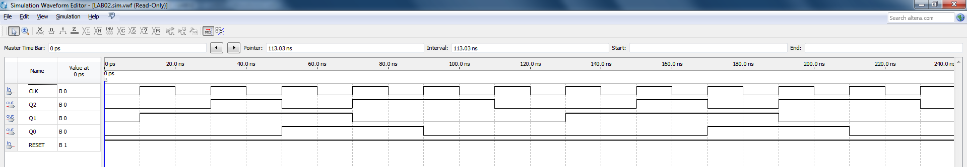

**Figure 3 : Simulation of 3 Bit Synchronous Counter with JK Flip-Flops**

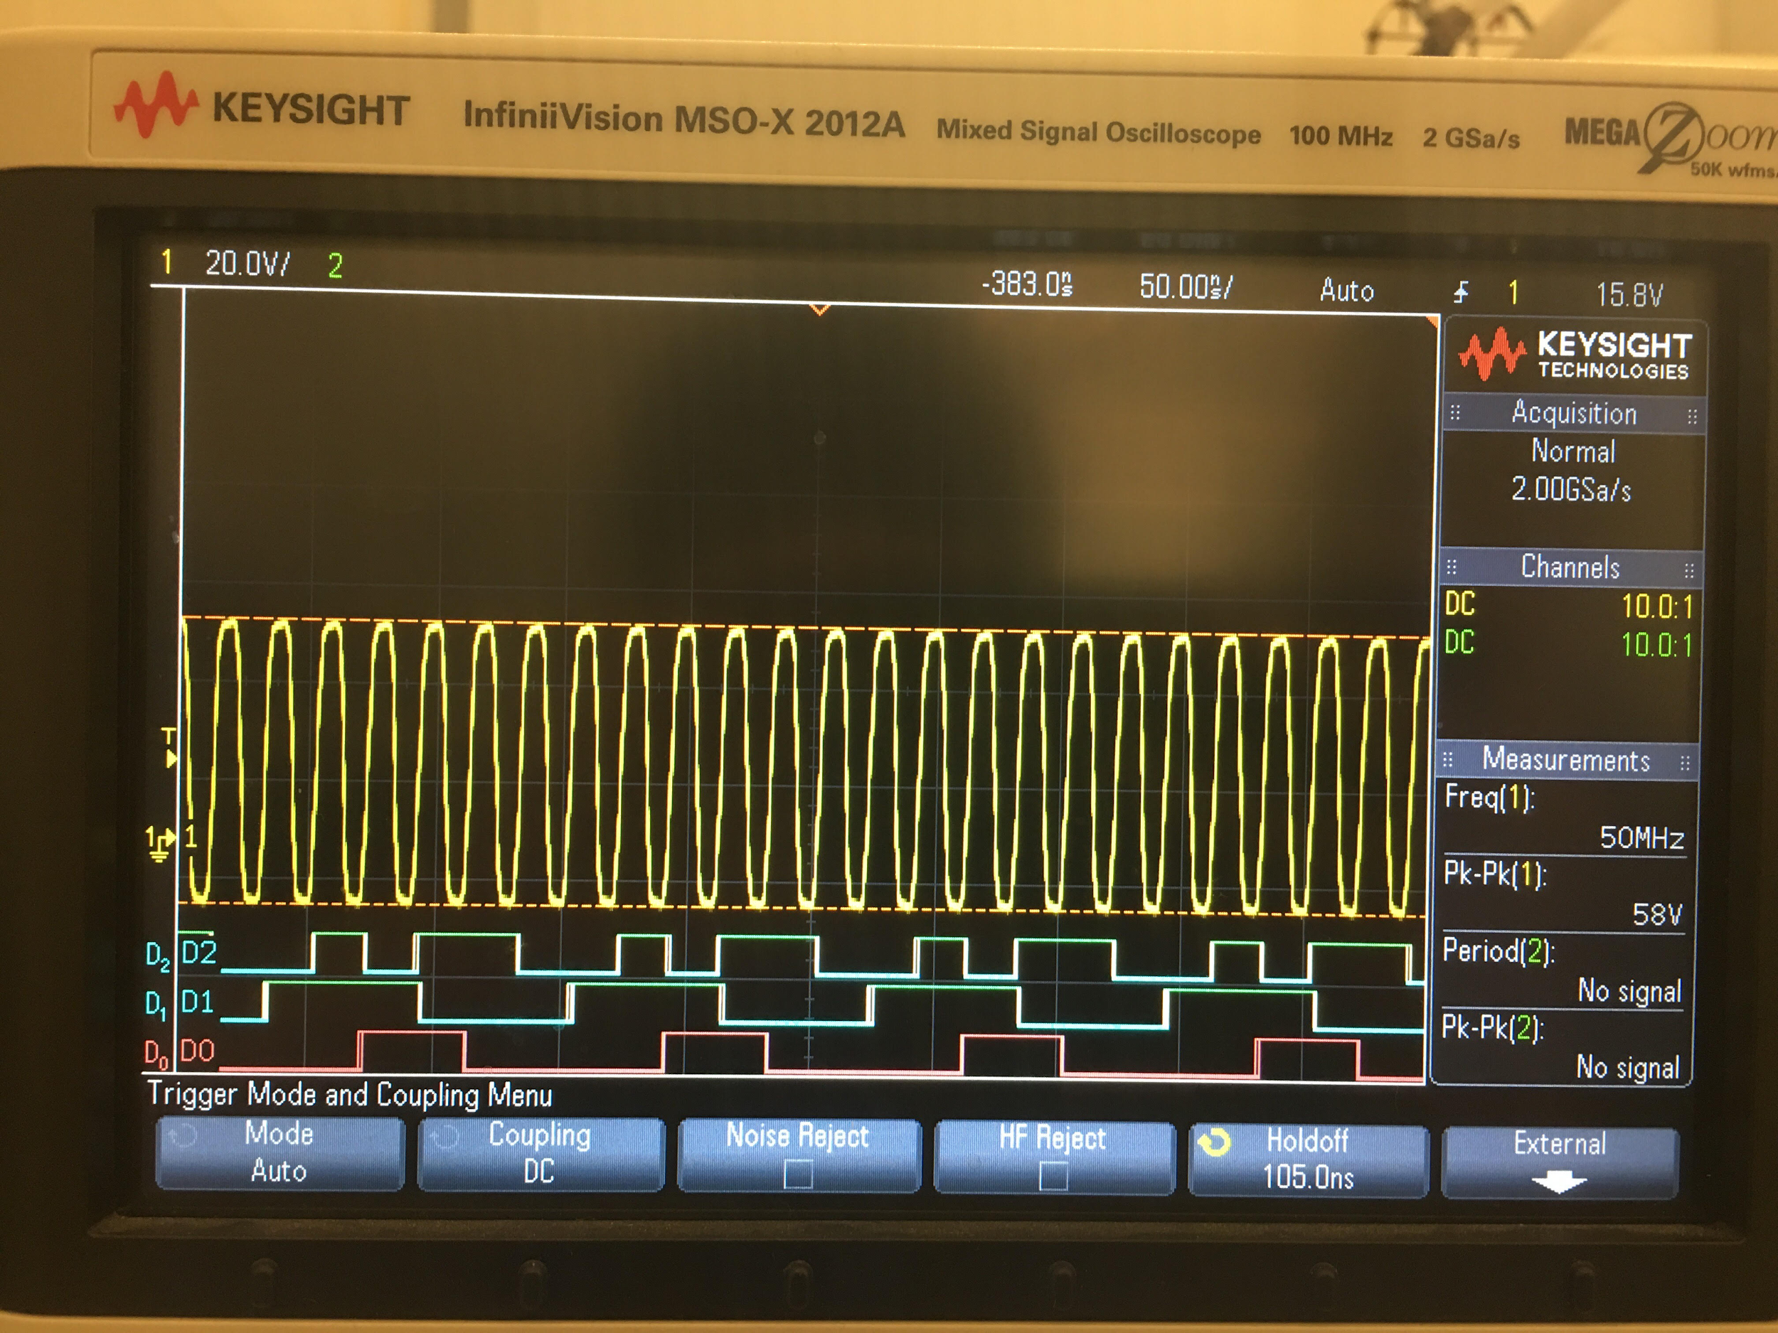

**Figure 4 : Oscilloscope Display of 3 Bit Synchronous Counter with JK Flip-Flops**

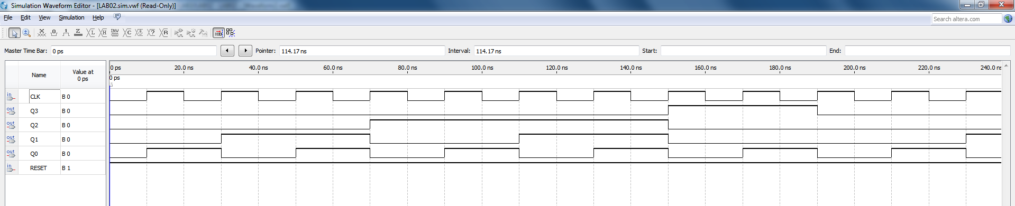

**Figure 5 : Simulation of 4 Bit Synchronous Counter with JK Flip-Flops**

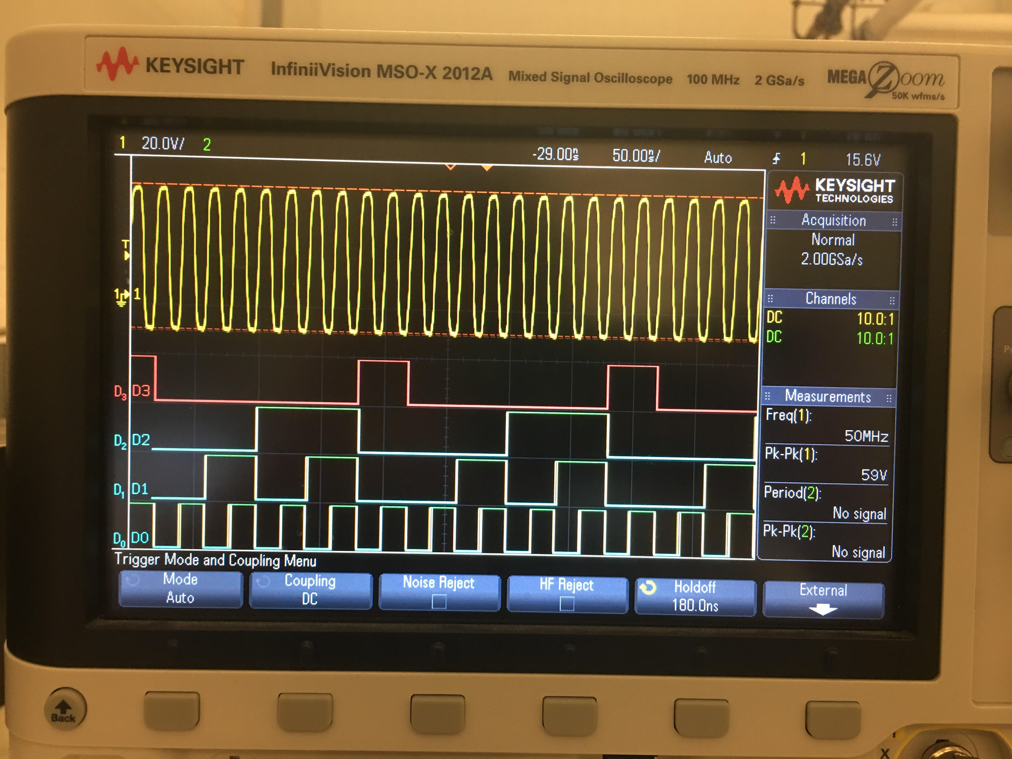

**Figure 6 : Oscilloscope Display of 4 Bit Synchronous Counter with JK Flip-Flops**

|  |  |  |  |  |  |  |
| --- | --- | --- | --- | --- | --- | --- |
| **CLK Number** | **Theoretical Output** | | | **Experimental Output** | | |
| **Q2** | **Q1** | **Q0** | **Q2** | **Q1** | **Q0** |
| **1** | 0 | 0 | 0 | 0 | 0 | 0 |
| **2** | 0 | 1 | 0 | 0 | 1 | 0 |
| **3** | 1 | 1 | 0 | 1 | 1 | 0 |
| **4** | 0 | 1 | 1 | 0 | 1 | 1 |
| **5** | 1 | 0 | 1 | 1 | 0 | 1 |
| **6** | 1 | 0 | 0 | 1 | 0 | 0 |

**Table 1 : Theoretical Data vs. Experimental Data Observed from the Altera DE2-115 Card Circuit for 3 Bit Counter**

|  |  |  |  |  |  |  |  |  |
| --- | --- | --- | --- | --- | --- | --- | --- | --- |
| **CLK Number** | **Theoretical Output** | | | | **Experimental Output** | | | |
| **Q3** | **Q2** | **Q1** | **Q0** | **Q3** | **Q2** | **Q1** | **Q0** |
| **1** | 0 | 0 | 0 | 0 | 0 | 0 | 0 | 0 |
| **2** | 0 | 0 | 0 | 1 | 0 | 0 | 0 | 1 |
| **3** | 0 | 0 | 1 | 0 | 0 | 0 | 1 | 0 |
| **4** | 0 | 0 | 1 | 1 | 0 | 0 | 1 | 1 |
| **5** | 0 | 1 | 0 | 0 | 0 | 1 | 0 | 0 |
| **6** | 0 | 1 | 0 | 1 | 0 | 1 | 0 | 1 |
| **7** | 0 | 1 | 1 | 0 | 0 | 1 | 1 | 0 |
| **8** | 0 | 1 | 1 | 1 | 0 | 1 | 1 | 1 |
| **9** | 1 | 0 | 0 | 0 | 1 | 0 | 0 | 0 |
| **10** | 1 | 0 | 0 | 1 | 1 | 0 | 0 | 1 |

**Table 2 : Theoretical Data vs. Experimental Data Observed from the Altera DE2-115 Card Circuit for 4 Bit Counter**

**Experimental verification of Operation of the Circuit:** As seen above, our theoretical data was a match to the experimental data, achieved by loading our circuit onto the Altera board and testing each combination, meaning that our design was correct and the outcome expected. Our simulation followed a path that was described in our pre-lab.

**Conclusion:**This lab did not contain any problems for us and the results given at the end were exactly what we predicted the 3 bit counter should count, 000, 010, 110, 011, 101, and 100 then restarting. The 4 bit counter should then count 0000, 0001, 0010, 0011, 0100, 0101, 0110, 0111, 1000, and 1001 then restarting. We used the simulation to test our truth table and we were able to conclude that our design and derived truth table was correct. At the end we were able to further our knowledge of the QUARTUS software and the oscilloscope functionalities.

**Appendix:**



